Programme Architecture

Hira Programme




Document Information
Status | Location | Author
DRAFT | Hira Programme Architecture.docx | Bryce Watkins, Anthony Benson

Version history
Date | Version | Status | Comments
1 May 2023 | 0.1 | DRAFT | Initial Draft
23 May 2023 | 0.2 | DRAFT | Updated text and diagrams
9 June 2023 | 0.3 | DRAFT | Updated Technology Dependencies Map section, Stakeholders consulted and the Glossary.

Consultation
The following stakeholders, in no particular order, have been consulted regarding the content of this document.
Name | Role | Organisation | Review Status
Peter Marks | Enterprise Architect | Ministry of Health
Heath Tolley | Head of Integration | Te Whatu Ora
Matthew Smith | Enterprise Architect | Te Whatu Ora
Ross MacLennan | Application Domain Architect | Te Whatu Ora
Daniel Thomson | Solution Architect | Te Whatu Ora
Bryce Watkins | Enterprise Architect | Te Whatu Ora
Debbie Brister | Enterprise Architect | Te Whatu Ora
Stephen Wong | Business Analyst | Te Whatu Ora
Hayden Smith | Business Analyst | Te Whatu Ora
Jannie Muller | Data Architect | Te Whatu Ora
Kathryn Jarden-Brown | Hira Product Manager | Te Whatu Ora
Becky George | Hira Clinical Team Lead | Te Whatu Ora
Dhareish Patel | Informatician / Pharmacist | Te Whatu Ora
Vidhya Makam | Data and Channels Lead / MDR Lead | Te Whatu Ora / Whanau Tahi
Sarndrah Horsfall | Manager Hira Data & Channels | Te Whatu Ora
Jennifer Rutene | Māori Health Director | Te Whatu Ora
Demetri Baroutsos | Hira Technical Lead | Te Whatu Ora
Gerard Keenan | Hira Delivery Director | Te Whatu Ora
Andrew Ingersoll | Clinical Principal Advisor | EY Contractor
Michael McEwan | Business Analyst | Te Whatu Ora
Nigel Robson | Project Manager (Service Mgt) | Te Whatu Ora
Liz Rose | Project Manager (ENS) | Te Whatu Ora

Related Documents
Document Name | Link
Hira Detailed Business Case | HIRA DBC Architecture v2.1.docx
Hira Tranche 1 – High Level Requirements | Hira Tranche 1 - High Level Requirements .docx

Approval
Name | Role | Signature | Date | Approved?
Demetri Baroutsos | Enablers Technical Lead
Gerard Keenan | Enablers Delivery Manager

Table of Contents
1. Purpose 6
2. Business Context 7
3. Solution Context 8
3.1. Stakeholder segmentation 9
4. High Level Approach 10
4.1. Connector Platform Overview 11
4.2. Data Sourcing Approach 14
5. Connector Platform “Floorplan” 16
5.1. Systems of Engagement 16
5.1.1. MarketPlace 16
5.1.2. Customer Relationship Management 17
5.1.3. Developer Portal 17
5.2. Connector Platform 17
5.2.1. Connector Plane 17
5.2.2. Integration Platform 20
5.2.3. Data Services Platform 24
5.2.4. Hira IdAM Platform 31
5.2.5. Event Notification Platform 42
5.2.6. Core Cloud Platform 44
5.2.7. Security 47
5.2.8. Observability 47
6. Information View 49
7. Architecture Principles 51
8. Deployment Considerations 53
8.1. Scalability 53
8.2. Resilience and fault tolerance 53
8.3. Disaster recovery 53
8.4. Security, monitoring, and observability 53
9. Delivery Approach 54
9.1. Architecture Development Method 54
9.2. Procurement and Operating Model Approach 54
9.3. Technology Dependencies Map 55
10. Variations from DBC Architecture 56
11. Risks, Assumptions and Decisions 57
11.1. Architecture Risks 57
11.2. Architecture Assumptions 57
11.3. Architecture Decisions 58
12. Glossary of Terms 59

Purpose
This document provides an opportunity to ensure key stakeholders and decision-makers have a shared understanding of the future state of the programme, including what needs to be built, how it will be deployed, and how it will realise business objectives. The document aims to remain high level yet still provide enough detail that decision makers can sign off the overall direction of the Programme. Simultaneously the document aims to provide sufficient context for the technical audience so that they can understand the building blocks of the solution, and how the individual components fit together to enable more detailed solution architectures to be developed.

Business Context
A Te Whatu Ora team is working in partnership with consumers, the health and disability sector, and technology providers to deliver Hira.
Hira is a connector that links an ecosystem of data and digital services to enable people’s health information to be accessible in a trusted and secure way. It will transform the way people interact with health services and use their health information.
Hira is a te reo Māori word that means ‘to have a significant bearing on future events’, and to have a ‘widespread effect’. The name speaks to the Hira promise of better health outcomes for all New Zealanders.
Te Whatu Ora is engaging with consumers and whānau throughout the design, development, and implementation of Hira.
Better access to health information – anywhere, anytime
Hira enables access to a virtual electronic health record by drawing together a person’s latest health data from trusted sources to create access to that data as needed. Consumers will have better access to their health information and can control who they share it with. Providers will have secure, easy access to patient information, in the right context and at the right time.
Hira is focused on:
- Improving equity of access to health information and health services; empowering and supporting consumers and whānau to better manage their health and wellbeing; and improving the performance of the health system.
- Providing access to data and digital services that make health information more accessible and interoperable, and result in better quality data for improved insights and decision-making.
- Making it easy to use Hira data and digital services so that they are adopted widely in the sector and support improved system and market innovation.
Improving Māori health outcomes is a priority. Hira will target equity challenges and identify ways to address these. The principles of Māori data governance will be incorporated.
Why change is needed
- Many of our health and disability information sources are not joined up, and there is variation in how data is collected and stored, and in its quality.
- Data is not always accessible to help a person receive the best health care for their needs.
- It is not easy for New Zealanders to access or control their own health information, or to share it with trusted family and whānau.

Solution Context
The Health Sector is a complex ecosystem of interconnected systems with a considerable use of legacy integration and information exchange protocols. Data is stored in silos in each system and often copied from one system to another. There is no mechanism to propagate notification of changes in systems of record to other systems leading to stale, out-of-date information.
Ross MacLennan has put together and excellent overview presentation that provides a sense of the complexity involved. The following image of the primary sector provides a GP centric view of the sector. The page Solutions Landscape and subpages provide other views from other perspectives of the Health Sector.
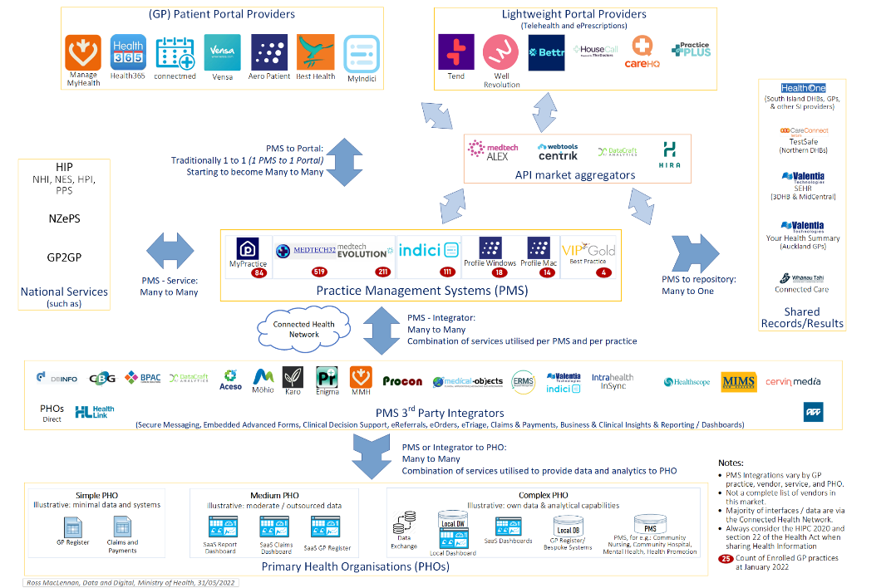
When considering the architecture of the sector from the perspective of Hira, parallels with a Microservices architecture can be seen, simply at a larger scale. Similarities include:
- Governance is decentralised and distributed, as Providers of Health Sector systems are motivated to meet their customers' needs with their products, therefore the design of the products are not managed centrally.
- Each System is an independent instance, often deployed to its own infrastructure and with its own data store.
- Has data replication and consistency challenges via Systems of Record and/or Sources of Truth updating other Systems of Record and/or Sources of Truth, such as Labs Systems and or Immunisation Systems updating Patient Management Systems, or Patient Management Systems updating the e-Prescribing System.
These properties are what contribute to the complexity of the system and care must be taken when introducing further connectedness. Approaches used when dealing with a Microservices architecture will be considered and leveraged where appropriate for the Hira Architecture.

Stakeholder segmentation
The following primary user groups and stakeholders have been defined in the context of Hira.
Health Service Consumers | Are defined as you and me, i.e. everyone who is an end-user of health services.
Health Service Workforce | Both Providers and Practitioners have formal definitions, but Hira is concerned with a wider definition, currently defined as the Health Service Workforce, which includes all people who work in the Health Sector for Providers whether they are a registered Practitioner or not.
Developers | Developers refer to the technology development partners in the sector who are provider technology services to the Health Sector. These range from large incumbent vendors through to small innovators. They are also further decomposed into two roles they can participate in with respect to the Hira Connector. The first being the Digital Service Consumer and the other being the Digital Service Provider. The Digital Service Consumer role is the developer who is consuming Hira Connector Products to deliver services to either Health Service Consumers or the Health Service Workforce. The Digital Service Provider is the role a developer or vendor operates in when they are providing data to the Hira Connector Products. It is quite conceivable that some Developers will operate in both roles.
Policy and Planners | Policy writers and funding and planning staff will be interested in service usage information to determine where value is being created from the Hira ecosystem. Fundamentally the platform will have a cost to run and therefore an ability to identify benefit against cost will be an important consideration for this stakeholder group.
Researchers | Researchers will want to leverage data about the Health Sector and Hira intends to provide Health Service Consumers with greater control and visibility of where the data is used. This in turn is expected to benefit researchers by enabling them to be able to access more data for research purposes.
External Agencies | Parties who are involved with delivering products and services to Health Service Consumers and/or Health Practitioners/Providers. The typical focus of this group of stakeholders and how they differ from described stakeholders, is that they are often involved with transactional delivery of services but exist outside the definition of the Health Service Workforce. Examples could include other government agencies delivering wellbeing related services, such as MSD.

High Level Approach
A key goal of the programme is to foster innovation and development of new and useful services that support both Consumers and the Workforce but do so in a safe and trustworthy way. The delivery of Hira is being approached in three primary layers, with additional services outside Hira leveraged where appropriate. These primary layers separate the Information Products (the APIs) and the Data Sources with a Connector Platform that provides sets of reusable services to the Information Products and bridges any capability gaps in the Data Source layer. The components of each layer are further described below.
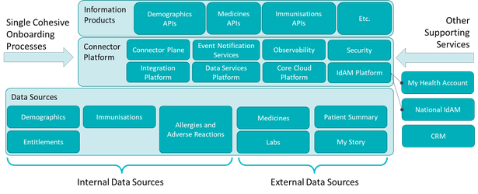
The programme will build an initial set of base Information Products (APIs) to meet business case objectives and allow other parties to contribute and enhance the Information Product ecosystem further over time.
When building both Products and Platform, the approach taken will be to first determine platform capability requirements for the Products identified in the Tranche 1 business case, prioritise these requirements and then identify technology solutions and suitable delivery resources. A combination of delivery resources will be used from both within and outside of Te Whatu Ora. However, governance of the designs will remain the responsibility of the programme, both in terms of ensuring the component parts integrate successfully and are able to meet functional and non-functional requirements.
To maintain traceability of requirements, meet information security assurance requirements and efficiently deal with on-going change impacts, the designs of the platform and products that are delivered by the programme, will be modelled in appropriate model languages, and stored in a toolset that supports performing analysis of the models. Further details are provided in the section Architecture Development Method.

Connector Platform Overview
The Hira Connector Platform encompasses a significant amount of technology capability. Therefore, to enable efficient delivery, the platform has been decomposed into components to allow parallel delivery by multiple teams, whilst also aligning to Vendor’s product offerings in the market.
The below diagram provides a high-level view of the Building Blocks of the Hira Tranche 1 target state. The building blocks represent both technology capabilities as well as non-technical building blocks that will be developed, reused, or extended as part of the delivery of the programme.
Details of the building blocks are expanded upon in upcoming sections of this document.

Component | Description
Connector Plane | The Connector Plane is the component where all APIs will be surfaced and be interacted through. It provides governance, management, and security services for the APIs. It is also integrated with the IdAM component for Identity and Authentication, and Authorisation Services.
Integration Platform | Integration Platform provides connectivity services and runtime environments to host APIs. It also provides services to monitor API health and provides supporting services to assist with translating between different protocols and information formats.
Data Services Platform | The Data Services Platform provides capabilities to store data and manage data (including the location of records), the ability to ingest from disparate types of data sources and data formats, and the ability to detect and manage data quality issues. The service also includes services to provide semantic consistency, so that the meaning of the data is understood, known as Terminology Services.
IdAM Platform | The IdAM Platform (Identity and Access Management) includes the capabilities and services required to Identify different cohorts of users, be they a Health Service Consumer (HSC), Providers, Developers or Te Whatu Ora staff members, authenticate them, and determine authorisation decisions for operations they wish to perform. This component will leverage and where required, drive forward the wider organisational strategy for delivering IdAM Services. This includes expanding to the Privacy Centre concept to achieve the requirements for HSCs to consent to information use by Providers, or delegate rights to another HSC to access information and operate on their behalf.  The IdAM component will need to leverage policies created for operations that can be permitted or delegated to records of information described by the Logical Data Model.
Event Notification Platform | An Event Notification Platform (also known as ENS) is simply a broker that links publishers (producers) of events to subscribers (consumers) who are interested in timely access to the event data. An event represents a real-world occurrence of a Health Sector business event, such as a person changing their name in the NHI, a new lab result being recorded, or a prescription being created.
Cloud Platforms | The Cloud Platforms represent the core Cloud services that will be utilised to run the Connector Platform and it associated components. It is anticipated that more than one Cloud Vendor’s services will be needed to support the connectivity requirements of Hira. Note that this component will also include cloud to on-prem network connectivity components as required.
Observability Services | Observability contains several related sub-components, these include:  - audit logging for Health Service Consumer visibility and investigative purposes,  - logging, alerting, and monitoring for operational purposes,  - logging, alerting, and monitoring for Security purposes, this component integrates with the Security Services  - business metrics covering system usage and value  Observability Services rely on integration with other components for the supply of data to achieve its purpose. However, to prevent repeated and disjointed silos of observability information being created, a shared set of capabilities will be leveraged where feasible or developed when not.
Security Services | Security Services helps ensure appropriate security processes and capabilities are in place to enable delivery and operation of secure consumer, provider, and data services, whilst maintaining speed to market of the services.
Channel  (Systems of Engagement) | Describes the components that provide a means for people to learn about and interact with Hira services.
Supporting Resources | Represents the artefacts and knowledge required to successfully utilise and contribute to the Hira ecosystem. Many of these resources will be made available via the Systems of Engagement.
Operating Model | Describes the business services required to operate and maintain the Hira ecosystem.
FHIR Services | FHIR stands for Fast Health Interoperable Resources, and while it isn’t a component in its own right, FHIR Services are called out explicitly to draw attention to its importance. At present developing FHIR based APIs is still an emerging practice across the Health Sector, as such investment is required to mature the capability. This service will encompass the collection of Documentation, Practices, Tools and Standards and Guides to uplift the capability of building and maintaining FHIR based API services to a level sufficient for the Hira Programme to deliver it benefits.
Data Sources | Represents the data sources Hira needs to meet its objectives. From the earlier context of the Health System, much of the information needed to service these use cases is distributed across many data stores. These data stores can be classified in two important ways:  - Internal - those that Te Whatu Ora has a degree of control and ownership of. This includes data stores that may be operated outside the organisation but remain under direct contractual control.  - External - those who are owned and operated by parties outside Te Whatu Ora. Whilst they may currently have data supply agreements with Te Whatu Ora, it cannot arbitrarily stipulate how the data stores are implemented or behave.

Data Sourcing Approach
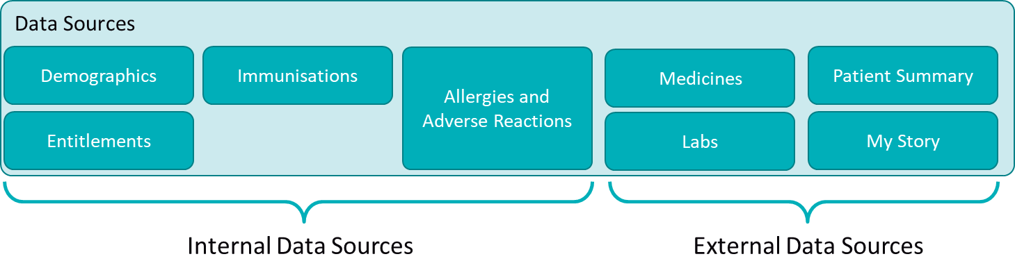
Te Whatu Ora will be jointly responsible with external organisations for making health data available via the Hira Connector Platform. This means ongoing supply of data from External Data Sources to the Hira Connector Platform will involve a partnership with the external organisations providing the data. This also implies a degree of joint management of the connectivity services through which the data products are made available via the Connector Platform.
In addition, there are considerable variations in availability levels and access speeds supported by these data sources, and in many cases, it is not feasible or appropriate to change the nature of the systems as they are often designed to support transaction processing business systems as their primary function, such as patient management systems.
This variability drives a need to have a choice of mechanisms for integrating with the data source, that are appropriate for the nature of the system. A key outcome of Hira is to abstract away some of this complexity to make it easier to build information products and services, in a secure and manageable way for both Hira itself and other innovators. To that end several scenarios and associated patterns for integrating with data sources have been developed. FHIR will be the preferred method of integrating with data sources, however where this is not feasible, alternative mechanisms will be utilised as outlined below.
As the requirements and data sources are identified for each Information Product, the detailed use case realisations will describe how appropriate sets of integration patterns, both deployment and behavioural type will be applied. Existing behavioural integration patterns are published here: Architectural Patterns of Integration
Both capabilities to read from the data sources and write to the data sources are required, however in many cases these capabilities will be implemented using different mechanisms. Information Products available for read can either match the native schema of the data source or vary considerably. For example, multiple data sources can be combined to create a richer information product, or a data source may be transformed from one coding scheme to another, e.g. LOINC to SNOMED. See Appropriate Layering of APIs for further rationale and abstract examples for read based information products.
Writes to Data Sources are far more complex because failure scenarios need to be considered and designed against to prevent data quality issues occurring. This is made even more complex when writes are not able to be made immediately against the data source and must be queued and completed asynchronously or utilise a workflow process to be checked before updates are allowed. Therefore, it is always preferable for writes to occur synchronously against the data source instead of asynchronously, and the write transaction to be as atomic as possible and aligned to the data source’s schema. However, when utilising workflows to modify data, it is likely to require the ability to display the fact that an update to a record is pending so the user is aware that the information is under revision.

Scenario | Description
Internal Data Source | In this scenario the data source is within Te Whatu Ora’s control. The specification of the System API, Process and Experience APIs are also entirely within the control of Te Whatu Ora. Any writes or updates can be designed to minimise complexity.
External Data Source via API | In this scenario the data source is provided by an external agency and can be integrated with in real-time via an API interface, which may or may not be FHIR based. The specification of the System API(s) is the responsibility of the external agency.  Any Process and Experience APIs may be provided by either the External agency or Te Whatu Ora or both and will leverage services from the Hira Connector Platform.  Any writes or updates need to be designed with the external agencies collaboration to minimise possibility of data quality issues.
External Data Source via Cached Data | In this scenario the data source is provided by an external agency and is not able to be integrated with in real-time, rather a data synchronisation/ETL mechanism will be utilised to populate a data cache hosted within the Hira Connector Platform. The cache will then offer a System API(s).  Any Process and Experience APIs will be provided by Te Whatu Ora and leverage services from the Hira Connector Platform.  Writes/Updates to cached data will not be supported in Tranche 1, as per Trusted Data Sources section of Hira Tranche 1 High-Level Requirements).

Note, there is also a need to cater for situations where Developers do not wish to leverage the Hira Connector Platform but do want to make the sector aware of a service they are offering via the MarketPlace. This situation is colloquially known as Signposting only, where no assurance is offered to the nature or quality of the information by Hira.

Connector Platform “Floorplan”
The following diagram and sections describe how the Connector Platform will be deployed and utilised. Also shown are technology choices where they are known at the time of writing.

Systems of Engagement
The Systems of Engagement are used primarily by Developers and technology professionals to understand what information and services are offered by the platform, allow people to enrol to utilise the services, through to providing technical and supporting services necessary to successfully develop, test and manage applications which utilise Information Products.

MarketPlace
The MarketPlace is a Web Content Management Systems that hosts a catalogue of services that the platform provides. It allows authenticated users to collaborate and maintain content about services by integrating document management, digital asset management and record retention functionality. This content is then used by unauthenticated users to obtain information about services they may be interested in. It will then direct them to an onboarding/enrolment process supported by the CRM platform.

Customer Relationship Management
The CRM Platform provides services to support the workflow of onboarding Developers and people interested in consuming Hira Services. It also maintains details about customers, such as contact information and iterations that are had with them. Support Staff who help support customers are a key user of the system. The existing Salesforce platform will be utilised to provide CRM required functionality.

Developer Portal
A Developer Portal provides technical information about APIs, including the API specification itself. They also include mock versions of the APIs for developers to try out. Developer Portals also allow restricting API information to only authorised Developers, who have met any specified usage requirements. Developer Portals are often provided as a component of and API Management platform due to the tight integration between the API Manager component and the Developer Portal. The MuleSoft Anypoint API Community Manager has been selected to provide Developer Portal functionality for the Connector Platform.

Connector Platform

Connector Plane
The Connector Plane integrates several technology components with policies, standards, and procedures to make API Information Products available to the sector in a secure and manageable way. Key technology components of the Connector Plane are an API Manager and API Gateways.
The API Manager provides a single interface and repository for API control policies and API performance information. API Gateways are deployed as needed close to where the APIs themselves are hosted. The Gateways obtain control policies from the Manager to provide security and access controls for the APIs they service. This is key to reducing the risk of malicious use of APIs that are published to untrusted networks such as the internet. The API Gateways also communicate back to the API Manager usage and performance information, including alerts when thresholds are exceeded, or errors occur.
The Connector Plane leverages other components of the platform to provide the required functionality. As previously discussed, the Developer Portal is integrated with the API Manager to publish API specifications to the Manager which are then enforced in the API Gateways.
The Connector Plane leverages services from the IdAM Platform to authenticate users and systems using the APIs. IdAM platform services are also used to authenticate users accessing the API Manager to manage and monitor APIs.
The API Manager is integrated with the Observability Platform to log usage information and send alerts for action by operational staff. This also provides visibility into malicious API use and is a key information security measure to mitigate the risk of unauthorised access to information.
The Connector Plane also connects to the APIs themselves to publishes them, but it does not host the APIs, this is the role of an integration platform which is described in the next section.
By utilising a single, Connector Plane integrated with the Developer Portal, the MarketPlace, the IdAM and Observability Platforms, a single source of accurate truth can be created about all the APIs available in the Health Sector, and thereby drive innovation by making detailed information about them available to Developers in one place.
The MuleSoft API Management Platform has been selected to provide the Connector Plane services, and it will deliver the following capabilities:
Capability Hierarchy Number | Name | Description/Definition
3.1.1 | API Management | API Management is the process of creating Application Programming Interfaces (APIs), defining, and enforcing usage policies, controlling access, collecting, and analysing usage statistics, reporting on performance, and interacting with subscribers. An API management platform is a tool that acts as a proxy for customer requests to protect the back end of an online service from being brought down from too many queries.
3.1.1.10 | API Observability | The ability to capture, record and present infrastructure and inflight processing events in a near-realtime and historic perspective
3.1.1.10.1 | Usage Metrics | Service requests associated with a subscription, application and organisation are persisted for later reporting and presentation. Logged metrics must support the production of required service metric and usage reports.
3.1.1.10.2 | Usage Metrics Consolidation | Solution must be able to consolidate recorded service metrics by a configurable time period (e.g., consolidate all metrics for a given hour down to a single entry) while preserving the ability to report in other dimensions (e.g., consuming subscription key, consuming application, and API Service).
3.1.1.10.3 | Diagnostic / Debugging / Development Monitoring | The state of API Management componentry is available for retrospective analysis in support of determining root causes of issues.
3.1.1.10.4 | Alerting | Monitor API Traffic patterns and provide alerts where limits are reached or anomalous states are detected.
3.1.1.10.5 | SIEM Logging | The solution must be able to provide required logging data to the enterprise SIEM solution in a near-real-time manner.
3.1.1.10.6 | Data Access Auditing | All API Service requests must be recorded to persistent and immutable storage and information related to the event that it complies with the relevant auditing standard (e.g., who, when, what and context).
3.1.1.16 | Simple API Caching | Supports the caching of data at the boundary to support latency and data read efficiencies.
3.1.1.2 | API Manager | The collection of a set of policies, Role based access, and other information needed to control and enforce policies across a set of managed API gateways
3.1.1.2.1 | API Profile Policy Management | The ability to apply global or service/operation specific policy to secure, constrain or otherwise affect the availability or functionality of a service. Examples - authentication, geo-blocking, rate-limiting, quota usage, throttling and payload encryption.
3.1.1.2.2 | Service Deployment | Management and deployment of service specifications, resulting in services being made available.
3.1.1.2.3 | Service Specification / Supporting Collateral | Extension to the deployment of services where additional collateral associated with a service is managed and deployed / made available for consumer discover and use.
3.1.1.2.4 | Deployment Change Auditing | All changes to API management components and capabilities must be recorded and responsibilities monitored.
3.1.1.2.5 | Provider Organisation & User Onboarding | The ability to provide DevSecOps access to product teams, belonging to a given collaborating sector partner (inc. HealthNZ), charged with delivering specific sets of services, whilst limiting access to all other services managed within the same governance plane.
3.1.1.2.6 | Provider API Service Certification | Describes the ability/process of certifying a service for inclusion within the test or production environments
3.1.1.2.7 | API Administration Governance | Provides a management capability for a collection of API Gateways supporting given governance plane.
3.1.1.2.8 | Mock Services | Provides an ability to create mock versions of production APIs with synthetic data for the purpose of developers to gain a richer understanding of the functions of the API
3.1.1.9 | API Gateways | Core API traffic management component, deployed per environment or product team for the publication of services and the routing of traffic through to the desired endpoint. An API gateway is programming that sits in front of an application programming interface (API) and acts as a single point of entry for a defined group of microservices.
3.1.1.9.1 | API Traffic Usage Accountability & Billing | Associate accountability (optional billing) for usage of given API Services & Operations to the consuming entity.
3.1.1.9.2 | API Traffic Monitoring & Auditing | Core API traffic management component, deployed per environment or product team for the publication of services and the routing of traffic through to the desired endpoint. An API gateway is programming that sits in front of an application programming interface (API) and acts as a single point of entry for a defined group of microservices.

Integration Platform
An Integration Platform provides an environment to run integrations (such as APIs) thereby allowing one system to connect and communicate with another system. It also includes supporting services that make developing integrations quicker to build and simpler to operate. Integration Platforms are provided by several vendors and is often be bundled as part of a Vendor’s Cloud Offering.
For Hira several Information Product APIs will be built, which will integrate to Data Sources to provide information to consuming systems. To do this an environment is required to host the APIs which makes it cost effective to develop and run our APIs. This is what our Integration Platform provides.
The following table describes the capabilities to be provided by an integration platform. Evaluation of Vendor’s product offerings will be carried out to select a vendor that can best meet our requirements.

Capability Hierarchy Number | Name | Description/Definition
3.1.2 | Orchestration "Rules and Workflow" | Provides facilities to create and manage workflows and associated rules on which conditional events can be described and made to effect the traversal and behaviour of the workflow.
3.1.2.1 | Simple API Traffic Orchestration | Provide the ability to interrogate API traffic requests and route traffic according to rules associated and configured as part of the API deployment.
3.1.2.2 | Business Rules/Process / Workflow / Messaging Platform | A discipline in operations management in which people use various methods to discover, model, analyse, measure, improve, optimise, and automate business processes. Workflow platforms let you build the two main parts of an automated process: a form to capture and validate data, and a workflow. A messaging platform is a set of tools that enables the flow and exchange messages between a provider and consumer.
3.1.2.3 | Business Rule Management System (BRMS) | is a component used to define, deploy, execute, monitor, and maintain the decision logic for an organization. A technology system used to capture decision logic as a business rule, which is then automated across applications. Instead of embedding rules as code within multiple applications, with a BRMS, the rules are externalised and managed away from application code.
3.1.2.4 | Business Process Management (BPM) | is a component used to automates the sequence of actions or activities required to complete a business process. This may involve documents, information or tasks being passed from one participant to another for action according to a set of procedural rules, each step of the process is tracked and can be escalated if not completed in a timely manner.
3.1.2.5 | Business Workflow Management | is the automation of a business process, in whole or part, during which documents, information or tasks are passed from one participant to another for action, according to a set of procedural rules. Two major components are typically used when implementing workflow these are:
3.1.2.6 | Message Brokering | Software or hardware infrastructure supporting sending and receiving of messages between distributed systems. Message Brokers provide an asynchronous communications protocol, meaning that the sender and receiver of the extract message do not need to interact with the message queue at the same time. Messages placed onto the queue are stored until the recipient retrieves them.
3.1.3 | Bulk Data Transfer and Streaming Platforms
3.1.3.1 | ETL Service | In computing, extract, transform, load (ETL) is the general procedure of copying data from one or more sources into a destination system which represents the data differently from the source or in a different context than the source.
3.1.3.2 | File Transfer | Secure File Transfer (SFT) provides the secure transfer of files in an efficient and a reliable manner. SFT core functionalities include the ability to secure files in transit and at rest, and the reporting and auditing of file transfer activity.
3.1.3.3 | Object Transfer Service | Provides secure blob storage and transfer capability. AWS S3 is becoming a generic standard with support now available in Azure as well as AWS. Able to replace SFTP with additional functionality to better handle transfer failures.
3.1.3.4 | Streaming Platform | Supports the transfer of continuous updated data from provider to one or more consumers.
3.1.3.5 | Protocol Translations | Transparently translates between communication protocols e.g., HTTP(S), JMS.
3.1.3.5.1 | HL7v2 to/from FHIR Transformation | The component provides the capability to convert event messages in HL7 v2 format into HL7 FHIR format compliant to an agreed release version of FHIR specifications.
3.1.3.5.2 | HL7 V2 to FHIR conversions | The component provides the capability to convert event messages in HL7 v2 format into HL7 FHIR format compliant to an agreed release version of FHIR specifications.
3.1.3.5.3 | SOAP Service Implementation | Platform supporting the implementation of SOAP services, including the provision of componentry necessary for available and scaled hosting.
3.1.3.5.4 | Content Transformation | Content transformation is the capability to transfer the content of data between different data formats and different digital formats.
3.1.3.5.5 | Content Based Routing | Content-based routing is used to examine messages and route them to the correct channel or destination depending on a message's content.
3.1.3.5.6 | Content Distribution Channel | Content distribution refers to the distribution of digital content via various communication protocols to either individuals, systems or data repositories, including sending data to printers or FAX.
3.1.3.5.7 | Content Enrichment | Content enrichment is one of the common integration capabilities for plugging in additional information of the existing content payloads for the benefits of the receiving systems or applications.
3.1.3.5.9 | Protocol Conversion | The capability to convert a standard or proprietary protocol of one device to the protocol suitable for the other device or tools to achieve the interoperability.
3.1.4 | Service Implementation Platform | Supports the implementation of all types of API Services
3.1.4.1 | Hosting Platform | Supports the deployment and hosting of APIs and integration logic
3.1.4.2 | API Framework & Libraries | Integration Frameworks, libraries and tooling to support the connectors, transfer, transformation and management of integration services.
4.4.8 | Data Load
4.4.8.1 | Change Data Capture (CDC) | The process of capturing changes made at a data source and making the data available to other systems.
4.4.8.2 | Data Replication | Replication - movement of data from one source to another in a single direction Synchronisation - movement of data between two sources bi-directional
4.4.8.3 | Data Synchronisation | Replication - movement of data from one source to another in a single direction Synchronisation - movement of data between two sources bi-directional
4.4.8.4 | Data Scheduling | The ability to schedule a job that triggers ETL

Data Services Platform
The Data Services Platform is used to store data when the Data Source itself cannot meet performance, availability, or security requirements. The platform is comprised of several discrete components which work in concert to enable Information Products to make data available to Sector systems. It also includes services to manage meta-data (data about data), for example what data means, and services to deal with Data Quality issues.
Terminology Services provide a repository and interfaces to access and maintain Terms, Codes, Synonyms and definitions of information used in clinical settings. This helps to ensure the meaning of information being exchanged is understood and defined in precise terms, which is a key requirement for Interoperability.
FHIR Services includes the tools and repositories to store and manipulate data in FHIR format and associated FHIR meta-data. This includes the ability to create FHIR API specifications, known as FHIR Profiles which are then published using these tools to Implementation Guides for Developers to consume to enable them to utilise a FHIR API correctly. For further information about FHIR Profiles and Implementation Guides and how they relate, see: https://fire.ly/blog/fhir-profiles-and-implementation-guides/
The Record Location Service is used to keep track of what data is available across which Data Source across the sector. Health Sector systems are oriented towards the Health Practitioners they are implemented to serve. Hira’s Information Products are designed to be Patient Centric. The Record Location Service is needed to bridge this mismatch by creating an index of every record that is available on a Patient-by-Patient basis. This way when an Information Product receives a request for information, it can know what Data Source it needs to get the data from. This includes knowing when a Data Source cannot service a request and instead the request should be directed to the Data Cache.
The Data Cache is used to store records from a Data Source when that data source cannot provide meet our non-functional requirements. In this case the data from their source will be cached in a database system in the Connector Platform that can service Information Product’s needs. The data will be loaded ahead of time and continuously kept up to date as new records are created using the Replication Services. The data in the cache may also need to be arranged in a different way than is stored in source system, such as converting a legacy coding system to a modern equivalent, or an API may need more data than a single data source provides, thereby needing multiple data sources joined together. This is the role of the Conforming Services.
The Conforming Services includes capabilities to transform data on both a scheduled basis and on demand. This includes editing tools, testing tools and repositories of rules to use to convert data one type or structure to another, and also engines to do the work of executing the transforms.
Replication Services include services to connect to remote data sources and populate the data cache. They can also track new records being created or records updated in the source systems and incrementally update the cache, which helps to ensure the source system is not overloaded and unable to perform its primary function.
Data Quality Services provide a set of tools which allow for the assessment and monitoring of a Data Source to determine whether the data in contains is of sufficient quality to be useful, and a score to be associated with it, so that users of the data can be informed of issues with the data.
The full list of capabilities to be delivered by the Data Services Platform are described in the table below. Vendor products will be assessed and evaluated against these capabilities to determine which best meets our needs.

Capability Hierarchy Number | Name | Description/Definition
4.2 | Data Quality | A platform concerned with the set of practices and tools that aim at maintaining a high quality of information. This involves the acquisition of data and the implementation of advanced data processes, to an effective distribution of data. It also requires oversight processes (governance) of the information of an enterprise.
4.2.1 | Data Cleansing | Removing invalid data from datasets
4.2.2 | Data Remediation | To correct data in place
4.2.3 | Data Profiling | Statistical analysis & sampling
4.2.4 | Data Entity Resolution | Mapping to known & defined entities
4.2.6 | Data Conflict Resolution | Ranking, sorting & prioritisation
4.2.7 | Match and Merge | a.k.a conflict resolution, entity resolution this function deals with identifying the same entity and its attributes used to de-duplicate, or rank data based on criteria, i.e. date last updated, provenance etc.
4.3 | Data Management
4.3.2 | FHIR Management | The ability to manage FHIR information schemas
4.3.3 | Structured Data | Schema is defined up front and strongly typed
4.3.4 | Unstructured Data | Schema is defined on read and not strongly typed
4.3.5 | Relational Data Management | Subtype of class structured data, highly structured and normalised with strong types and referential integrity
4.3.6 | Non-Relational / NoSQL Management | Subtype of class structured data, document oriented and supporting flexible schemas
4.3.7 | Operational Data Platform | A platform that typically deals with singleton transactions rather than batch or in aggregate
4.3.8 | Analytical Data Platform | A platform that typically deals with batch and aggregation rather than singleton reads
4.3.9 | Distributed Data | Often referred to as Data Virtualisation, when data remains at source but a view is brought together from distributed backend sources to present a single view
4.4 | Data Extract Transform & Load | Group that deals with the "middle" section of data, all movement capabilities and services that makes data flow between source and target. A.k.a. ETL, Data Pipeline
4.4.1 | Data Transformation | The data transformation manipulates the data to a suitable format
4.4.1.1 | Data Enhancement | Data Enrichment – the process that creates new information on the fly though derivation from an existing value. Example – Date of birth -> [calculated field] -> age
4.4.1.2 | Data Analysis \ Profiling | Data profiling is the process of examining the data available from an existing information source and collecting statistics or informative summaries about that data
4.4.1.3 | Master Data Integration | Special properties Master data – a property given to a dataset by an agreed and responsible authority when it is deemed an authoritative and original dataset given predetermined (re)-use of the data as form of guarantee or responsibilities. Master data used in another system it is called reference data.
4.4.1.4 | Reference Data Integration | Reference data sets from different sources will be rationalised to agreed standards. This capability will be assisted by the Terminology services capability.
4.4.1.5 | Data Masking | Hiding some information Masking - the process of hiding some data that may not visible (CRUD)
4.4.6 | Data Integration | Service and capability that deal with data in transit either directional or bidirectional
4.4.7 | Data Transformations | Data Transformation is the ability to transform data from one format to another. Transformation – the process of changing the structure of data. HIRA Example – Keywords in clinicians’ notes(unstructured) are changed to searchable by adding tags(semi-structured)
4.4.9 | Data Lineage | Data Transformation is the ability to transform data from one format to another. Transformation – the process of changing the structure of data. HIRA Example – Keywords in clinicians’ notes(unstructured) are changed to searchable by adding tags(semi-structured)
4.5 | Terminology Services Platform | Terminology services enable the programmatic access of terminology content in a consistent way. Centralising terminologies and representing them to disseminate predictable terminology content facilitates consistent meaning and shared understanding between users. Terminology services also ensure proper integration of other terminology-enabled software applications, optimal delivery of terminology artefact in harmony with a single consensus standard content model and data format.
4.5.1 | Terminology Platform | A terminology service is simply a set of functions built on the definitions provided by a collection of CodeSystem, ValueSet and ConceptMap resources, with additional inherently known terminologies providing support.
4.5.1.1 | Terminology Platform Management | The operational and support needed to deliver a terminology platform capability.
4.6 | Data Foundation - Data Pipeline | A platform concerned with the administration of data that describes other data whereby this "other data" is generally referred to as content data. The term is used most often in relation to digital media, but older forms of metadata are catalogues, dictionaries, and taxonomies. A metadata management tool is a technology, often a SaaS product used to store, organize, track, and edit every type of metadata within a business.
4.6.1 | Metadata | Metadata for operational and business function (clinical). The purpose of the meta data is to enrich the dataset. Metadata should help discoverability of data and includes services for the data catalogue and search.
4.6.3 | Metadata Classification | The ability to generate meta data automatically i.e. meta data discovery, auto classification, active meta data etc.
4.6.4 | Data Provenance | The ability to use metadata to provide evidence of provenance
4.6.5 | Data Catalogue | Data catalogue provides a view of all assets within the ecosystem by unique id. It could support versioning
4.6.6 | Business Glossary | A function of meta data, the platform should support the access of the meta data to end users.
4.6.7 | Search | The ability to search over meta data
4.6.8 | Technical Metadata | Technical metadata is data that describes the technical characteristics of a digital asset, such as a file or a database. It provides information about how the asset was created, how it can be accessed, and how it should be managed. Technical metadata may include information such as: 1. File format: The format of the file, such as JPEG, PDF, or MP4. 2. Compression type: The type of compression used to reduce the size of the file, such as JPEG or PNG. 3. Encoding: The method used to encode the file, such as ASCII or Unicode. 4. Resolution: The resolution of an image or video, measured in pixels. 5. Bitrate: The number of bits used to represent the audio or video data per unit of time. 6. Sampling rate: The number of samples taken per second in an audio recording. 7. File size: The size of the file in bytes. 8. Creation date: The date the file was created. 9. Modification date: The date the file was last modified. 10. Access permissions: Information about who has permission to access the file and what they are allowed to do with it.
4.7 | Data Storage Platforms | Storage – the process of how data is written to a digital mechanism for re-use, not including transit. Volatile - caching, hash tables, indexes and other temporary constructs to support optimized data recall typically system to system communication and disposable in nature. Non-volatile – Long term storage typically static, encrypted, original (not a copy) and typically protected against failure and loss.
4.7.1 | FHIR Platforms | A platform for the storage and processing of healthcare data in the format of FHIR resources.
4.7.2 | Relational Data | Data stored in a highly normalised form
4.7.3 | Non-Relational / NoSQL | Data stored in a document-oriented manner
4.7.4 | OLAP/Dimensional | Data structured ahead of time to support querying and analytical workloads
4.7.6 | Data Virtualisation | The process to logically centralise data
4.7.7 | National Record Location Platform | Describes a national service that records the location of prescribed data records associated with particular classifications of data, and services that either return the location and service by which the data can be retrieved, or (optionally) retrieve the data for the consumer.
4.7.7.1 | Record Location Services | The Record locator service platform provides interfaces to locate patient health records held by Sources of Truth and Systems of Record
4.7.7.2 | Record Location Catalogue | The Record locator catalogue is an electronic index of patient identifying information that directs providers in the Hira Connector Platform to the location of patient health records held by Sources of Truth and Systems of Record

Hira IdAM Platform
The Identity and Access Management Platform has two primary responsibilities and several additional supporting services. For Hira the primary functions are to 1) Authenticate users (both people and other machines) and 2) Authorise users to perform operations such as reading or changing data. Supporting services are services that help to manage the primary functions, such as monitoring for abnormal activity, automating the onboarding and offboarding of users, and providing reporting and auditing capabilities. IdAM services are a critical part of keeping information safe whilst providing access to it via an open network like the Internet.
Authentication is performed by the Identity and Authentication component, and for this component My Health Account will be used. This component maintains a database of users, their means of authenticating, such as username and password or alternate credentials such as RealMe. It also maps the digital identity to a business identifier, such as NHI or CPN. It also provides a set of standardised interfaces for other systems (such as the APIs hosted by the Connector Platform) to communicate via so that each one does not have to build their own authentication mechanisms.
Authorisation is expressed in a set of rules that permit or deny operations against records. The rules are applied to both the users and the information contained in each record. The Access Management component provides a set of services which allow the authoring, storing, and reporting on these rules. It also provides a set of standard interfaces to obtain the rules so that other systems (such as Information Product APIs) can ask whether a given operation for a given user is permitted, thereby allowing the centralisation of authorisation policies, and preventing systems having to build their own authorisation mechanisms in each individual system.
The full list of capabilities to be delivered by the IdAM Platform are described in the table below. National IdAM services, such as My Health Account will be leveraged to provide the capabilities required, with suitable standards, such as OpenID HEART, and additional technology solutions are identified to fill outstanding capability gaps.

Capability Hierarchy Number | Name | Description/Definition
7.1 | Identity and Access Management | Capabilities providing user identities & accounts to ensure only users with appropriate authentication & access permissions can access digital systems & information.
7.1.1 | Authentication
7.1.1.1 | User Authentication | User Authentication is a process that verifies a person's login credentials are correct. Includes common standard features for providing a range of authentication modes, such as same sign-on, single sign-on, session management, offline authentication, step-up authentication, string authentication and multi-factor authentication.
7.1.1.2 | Multi-factor Authentication | Multi-factor Authentication (MFA) is an authentication method that requires the user to provide two or more verification factors to gain access to a resource such as an application, online account, or a VPN
7.1.1.3 | Strong Authentication | Strong authentication is a way of confirming a user’s identity when passwords are not enough. Strong authentication is often confused with two-factor authentication (more generally known as multi-factor authentication), but strong authentication is not necessarily multi-factor authentication. Soliciting multiple answers to challenge questions may be considered strong authentication but, unless the process also retrieves 'something you have' or 'something you are', it would not be considered multi-factor authentication
7.1.1.4 | Single Sign On | Single sign-on (SSO) is an authentication scheme that allows a user to log in with a single ID to any of several related, yet independent, software systems. A range of implementation patterns (desktop, web, etc) will be necessary.
7.1.1.5 | Federation | Identity federation is a system of trust between two parties for the purpose of authenticating users and conveying information needed to authorize their access to resources. Federated identity is a method of linking a user’s identity across multiple separate identity management systems. It allows users to quickly move between systems while maintaining security
7.1.1.6 | Password-less Authentication | Password less authentication is a means to verify a user’s identity, without using a password. Instead, password less uses more secure alternatives like possession factors (one-time passwords [OTP], registered smartphones), or biometrics (fingerprint, retina scans).
7.1.1.13 | Certificate Based Authentication | Certificate-based authentication uses a digital certificate to identify a user, device, or machine, before granting application, network, or resource access
7.1.2 | Authorisation
7.1.2.1 | Machine learning based risk scoring | Use machine learning to track and analyse the login behaviour patterns of authorized users for a period of time to identify their normal login patterns. Each user is assigned a risk score based on their current login behaviour in comparison to previous similar login behaviour patterns
7.1.2.2 | Other iDP Integration | The ability to integrate to an external IdP which stores and manages digital identities for a different organisation. This include social platform IdP's such as Google
7.1.2.3 | Workforce Verification Services | An identity provider (IdP) that verifies digital identities or attributes of a digital identity. The IdP could also store and manage digital identities. E.g., Cloudcheck
7.1.2.5 | Adaptive Access | The ability to apply risk-based scoring to decide the appropriate authentication strength for access to a resource by a user.
7.1.2.6 | OAuth Authorisation Management | Management through the authorization framework which allows a user/system/api to grant a third-party web site or application access to protected resources, without necessarily revealing their long-term credentials or even their identity
7.1.2.7 | OAuth Token issuance & revocation | Access tokens are the thing that applications use to make API requests on behalf of a user. The access token represents the authorization of a specific application to access specific parts of a user’s data. The Token Revocation extension defines a mechanism for clients to indicate to the authorization server that an access token is no longer needed
7.1.2.9 | Attribute Based Access Control (ABAC) | The ability to make decisions about access to resources/systems/locations based on attributes of the user
7.1.2.10 | Claims/Attribute - mapping | Claim mappings are used to pass-through incoming attributes or roles, adding additional attributes as claim to all or specific accounts and/or mapping an incoming attribute to another (custom) attribute
7.1.2.12 | Role Based Access Control (RBAC) | The ability to make decisions about access to resources/systems/locations based on one or more roles that have been assigned to a user
7.1.2.13 | Session lifetime management | A session is a group of user interactions with a resource, such as an IdP service or an application (app), for a given amount of time. There are two types of sessions that you need to consider for managing the user experience—the IdP session and the application session.
7.1.2.14 | Consumer Verification Services | Services used by consumers and other end-users when accessing systems to verify their identity, using the knowledge and documentation they already possess, in order to confidently grant the access they need.
7.1.2.15 | Consent | IDAM services will support the definition and application of common consent features, such as constraining rules that reduce access to particular subsets of a person's data, subject to the full over-lay of access rules such as short-term escalation of privileges (break glass), well defined operational practices, and so forth.
7.1.2.16 | Delegation | Delegation/Guardianship, the ability to approve other individuals to access and manage one's data, subject to versatile choices to do so on a granular basis.
7.1.2.17 | Terms of Use Management | Systems will rely on a standardised external service to capture and refer to consent actions in relation to users joining a service, such as terms-of-use approvals, which will be identified by service, user, time, etc.
7.1.2.19 | “Break Glass” | The ability for a user to gain access to a consumer's information that they would not normally be able to access, for example in an emergency situation. Subject to suitable definition of comprehensive and integrated access rules.
7.1.2.20 | SoA Authorisation | The ability to apply authorisation decisions at various levels of a service-oriented architecture implementation
7.1.3 | Business Administration
7.1.3.1 | User Management | The ability to manage user rights and access to services and applications. User lifecycle management
7.1.3.2 | Role-Based Provisioning | The ability to automatically provision a user's account to specified systems and/or locations based on assignment of roles
7.1.3.3 | Role Certification | Role Certifications provide the ability to review users' roles, access profiles, entitlements, and apps to keep the sector safe and secure
7.1.3.4 | Role Life cycle Management | In role lifecycle management, user roles used for role-based access control (RBAC) are defined based on information about users (department, job function, location, etc.) to automate access and validate the appropriateness of entitlements that are granted.
7.1.3.5 | Access Review | The ability to trigger the review of a user's access privileges based on time elapsed since the last review or change in circumstances (job title change, etc.). Should include more generalised forms of access review, by group, role, area, attribute, etc.
7.1.3.6 | Password Management | The ability for the operational teams to manage password policies and assist end-users with password resets.
7.1.4 | IdAM Governance
7.1.4.1 | Access Certifications | Certification of a user’s access. Reviews will ensure certification is maintained, if missed policies can flag or remove access.
7.1.4.2 | Access Requests (reviewing/approvals) | The ability for a user who needs access to a new application or resource (like a network drive), can go to a dashboard where all the applications/services are listed. By requesting access, they are automatically provisioned — or, if needed, routed to their manager to approve the request — without having to resort to manual processes.
7.1.4.3 | Automated User/ Group Provisioning | The ability to automatically provision a user’s identity, account and groups used by a set of accounts/resources
7.1.4.4 | Policy Management | The ability to create technical policies used to govern access, authorisation and lifecycles of identities, accounts, applications, systems, and APIs.
7.1.5 | Self Service Management
7.1.5.1 | Password Reset and Change | The ability for a user to change or reset their own password without intervention from IT support or service desk
7.1.5.3 | Self Service Group Management | The ability to membership of one or more group, such as email distribution groups and other organisational structures not related to access privileges
7.1.5.4 | Third party authenticator Registration | The ability to register a third-party authenticator, such as a RealMe login account
7.1.5.6 | Access Requests and Approvals | The ability for a user to request access to additional resources not covered by their assigned roles, including the workflow processes for approvers to review and respond to access requests.
7.1.5.7 | Profile Management | The ability for workforce users to update editable information about themselves
7.1.5.8 | Self Service Registration | The ability for a consumer to register for an Identity in order to gain access to digital services
7.1.5.9 | Customer Data Management | The ability for consumer to manage the identity related data that is contained within the IDAM platform
7.1.7 | Systems Administration
7.1.7.1 | Managed Identities | Managed identities provide an identity for applications to use when connecting to resources. Applications use a managed identity to obtain Authentication tokens. The credentials are stored securely with in a Key Vault
7.1.7.2 | PaaS Identity Management | The ability to manage the Identities utilised with a Platform as a Service (PaaS) cloud service such as Salesforce. The management controls the access control and provides auditing for the service.
7.1.7.3 | Server and Devices Identity Management | The ability to manage the Identities accessing devices and services such as Windows Services or Medical devices. This is for IP connected devices and services that require access to services and require an identity in order to gain access. The management controls the access control and provides auditing for the service.
7.1.7.4 | Group Management | The ability to manage groups that contain a number of users or resources all requiring access to the same service(s). Provides a way to provide access control to more than one user or resource
7.1.8 | IDAM Specialist Support
7.1.8.3 | Exceptions Management | The ability for the operational teams to manage exceptions flagged within the platform which includes, role, access, duplication and security exceptions raised. This capability provides suggestions based on the exception type (e.g., identification of roles with the same access)
7.1.8.4 | Separation of Duty Enforcement | The ability to set SOD policies to be applied during provisioning, role assignment and access request workflows
7.1.8.5 | Centralised Administration | The ability to manage identities and account for a range of integrated systems and locations
7.1.8.6 | Delegated Administration | The ability to assign administration privileges to other for a limited scope, e.g. specific location, group of applications, group of users, etc.
7.1.8.7 | Application Management | The ability to manage the integration and configuration of applications to the IDAM capability as a defined system or resource for user provisioning, authentication, and authorisation
7.1.8.8 | Strong Authentication Management | The ability to integrate one or more strong authentication solutions, and define policies for when strong authentication is used
7.1.8.9 | Entitlement Management | The ability to define entitlements for combinations of functions, data and systems, and assign align entitlements with roles
7.1.8.10 | Coarse Entitlement | The ability to define high level entitlements, usually combinations of functions and systems/applications
7.1.8.11 | Fine Grain Entitlement | The ability to define detailed entitlements using a range of parameters that could include function, location, data, time of day, system/application, user attributes, etc.
7.1.8.12 | Workflow Management (Automation of tasks/process) | The ability to define a series of tasks as a workflow. This includes simple linear processes and complex multi-branch conditional processes.
7.1.8.13 | API Identity Management | The ability to manage how API are identified and how consume IDAM capabilities including how user authorisation is integrated into API processes
7.1.8.14 | Custom End User Experiences | The ability to provide tailored user experiences to consumers. Ability to modify the 'look and feel' of the channels used by consumers such as "My Apps" portals.
7.1.9 | Identity
7.1.9.1 | Systems of Record | Standardised authoritative identity sources for health consumers, providers, and workforce. These will be used as sources of well-defined and agreed standard static data, synced as required with other depending systems of record, such as NHI. The definition of HOW authoritative identity sources will be delivered, and the standards that further define and describe them, is a level of design detail that needs to be captured and agreed in greater detail, to deliver this capability.
7.1.9.2 | Workflow | Workflow orchestration is used to automate common business processes such as provisioning accounts, access requests, user access reviews, etc.
7.1.10 | Privileged Access Management
7.1.10.1 | Privileged Access / Just in Time | Just-in-Time Privileged Access Management (JIT PAM) is the method by which we can enforce “true” least privilege, to drastically reduce the threat surface.
7.1.10.2 | Session Management | The ability to which privileged users can access which systems, and which commands they can perform. Session management may also include dual control, session recording, and privileged user behavioural analytics
7.1.10.3 | Service/System/ Application Account Management | The ability to manage system/service/application-level accounts, applying password/key rotation policies, centralised management of passwords/keys, removing the need for long lived static system password
7.1.10.4 | Root/Admin User tracking/Shared Account Management | The ability to limit privileged user entitlements based on a variety of factors, and remove the ability to bypass the PAM protections through generated session specific passwords
7.1.10.5 | Command Management | The ability to restrict the set of commands a privileged user can execute within an access session
7.1.10.6 | Password Vault & Management | The ability to store system and account passwords in a central vault, manage access to them by role/privileges, and manage their lifecycle
7.1.10.7 | Request/ Approval Management | The ability to request and approve access to specific systems/commands based on a work request or incident management situation
7.1.10.8 | Admin Account Discovery | The ability to examine system and application account across the network to identify accounts they should be managed through the PAM password vault but are currently not included
7.1.10.9 | Session Recording/ Review | The ability to record activities undertaken through a privileged access session, and play them back at a later date for review
7.1.11 | Reporting, Auditing & Analytics | A suite of analytical capabilities, both operational and otherwise, to understand the operational and strategic state of the Identity and Access systems, services, and usage patterns, to inform operational and management decisions, and to fulfil monitoring and auditing requirements.
7.1.12 | Logging and event notification | Management and consumer capabilities to log particular events, and notify them in a range of ways, including notifying consumers of access events in relation to their information, and notifying operational teams of idiosyncratic or threshold events and behaviours.

Event Notification Platform
The Event Notification Platform listens for and distributes notifications of events that are happening across the health sector to technology systems that can derive a benefit by being informed about the events. The events themselves are business events, such as a patient attending an appointment, or a person dying. These are not technology events, and the platform is not to be confused with technologies that provide distribute event stores and stream processing platforms, although these technologies may become part of the solution for the Event Notification Platform.
The Event Notification Platform is also not intended to be used to distribute data changes to the systems that have subscribed to receive notifications, rather the intention is to inform the receiving system that an event has occurred and then let the receiving system act as it sees fit. This may include retrieving a new or updated record, such as an address change for a person, or it could trigger some other business process.
By implementing an Event Notification Platform, the accuracy of data and the efficiency of systems in greatly improved. This is because we remove the need for systems to continuously poll for changes to get information updates, or simply not get updated at all, resulting in stale data. Continuous polling increases the workload on both the initiating system and the system servicing the request, limiting the number of systems that can be supported and driving up the costs to do so.
The Event Notification Platform is comprised of the following capabilities.

Capability Hierarchy Number | Name | Description/Definition
3.3.1 | Event Publishing | Event handling is the receipt of an event at some event handler from an event producer and subsequently process the event payload based on the requirements of the downstream event recipients, then further publish or push to the predefined event subscribers The system should support different ways of event being consumed, (log oriented, queue oriented and subscription oriented). This will also include aggregation, enrichment, composition, mediation
3.3.2 | Event Insights | Event insight gathering is the process of collecting, analysing, and signalling insights from the frequency, source, patterns of the events and generate insightful events for subscribers.
3.3.3 | Event Management | This manages the event catalogue, schema, publishers, subscribers, topics, filtering rules, how the subscriber wants the events to be consumed. Streaming data is typically processed in real-time, although the type of data or the nature of events will affect any resulting action. This should be capable of once only delivery.
3.3.4 | Event Usage Monitoring | Reports generated from usage data collected from Event Data Management processing.
3.3.5 | Event Service Monitoring | Integrates with the Enterprise Service management platforms to enable the monitoring of the performance health of the capability.
3.3.6 | Event Persistence Management | Manages the persistence policies for the event and associated data associated with a particular event, storage policies and its life cycle management.
3.3.7 | Event Ingestion | An event messaging system manages the channels that define the paths of communication between the applications and the sending and receiving of messages.
3.3.8 | Event Playback | In some circumstances, it may be necessary for the event to be replayed for specific subscribers to allow catch up due to the subscribers down time
3.3.9 | Event Security Management | Implements the security policies for disseminating the event and related data to subscribers both at rest and in motion. This includes collaborating with other enterprise-wide functions to enforce authentication, authorisation, and encryption

Core Cloud Platform
The Core Cloud Platform represent the Platform as a Service (PaaS) and Infrastructure as a Service (IaaS) component that will be utilised to run the Connector Platform. Microsoft Azure has been selected as the primary Cloud service provider and networking, compute, storage, database and ancillary services will be utilised. The platform also includes an operating model aligned with the Te Whatu Ora Hybrid Multi Cloud Platform so that economies of scale and modern security good practices are used.
The Core Cloud Platform is comprised of the following capabilities.

Capability Hierarchy Number | Name | Description/Definition
6.1 | Cloud Platform | Complete set of appropriate Cloud Services from the Major Vendors
6.1.1 | Compute Platform | A compute platform is a data environment where software implementation occurs. The platform can consist of either the operating system (OS) framework or physical hardware architecture of the computer where the software execution occurs.
6.1.2 | Database Platforms | Platforms for deploying and managing various types of databases such as relational, NoSQL and in-memory databases.
6.1.3 | Digital Workplace & Productivity Services | The ability to allow end users to perform corporate functions using modern digital collaboration, communication, and office productivity tools. Includes both software services and hardware devices.
6.1.4 | Datacentre Platform | A data centre is a facility that centralises shared IT operations and equipment for the purposes of storing, processing, and disseminating data and applications. In this context it is not just Cloud Datacentre but also on-premises.
6.2 | Change and Release Management | Capabilities enabling the management of ICT change while mitigating the disruption & managing impacts to users of IT services
6.2.1 | Change & Release Management | Capabilities enabling the management of ICT change while mitigating the disruption & managing impacts to users of IT services
6.2.2 | Service Design, Delivery, Test & Validation | The ability to provide assurance that changes result in desired outcome and either no, or known negative effects which have been accepted
6.2.3 | Cloud Services Automation & Management | Cloud automation refers to the implementation of tools and processes in an effort to reduce the manual intervention associated with provisioning, configuring, and managing public, private, and hybrid cloud environments.
6.2.4 | Asset, Configuration & License Management | Asset, Configuration & License Mgmt is a combination of three important processes: Asset management which addresses the assets you use to deliver IT services. Configuration management which tracks the configurations of and relationships between the various components (configuration items or CIs) of your various IT services and License management which managed then license lifecycle and renewals
6.3 | IT Service Management | Capabilities supporting steady-state ICT delivery & support of user
6.3.1 | Operational Platform | An operational platform is where the management of an organisation's data and information takes place, together with the execution of decisions.
6.3.2 | Event, Incident & Problem Management | Event management process manages events throughout their lifecycle (from when they are raised until they are resolved). Incident is unplanned interruption (or reduction in quality) of an IT service. Incident management is a process which handles (record, diagnose, resolve) incidents throughout their lifecycle. Problem is cause of one or more incidents, where root cause of the problem is (usually) not known when problem is raised. Problem management is responsible to find root cause of (one or more) incident.
6.3.3 | Service Capacity & Availability Management | “Capacity management” is focused on how best to provide resources to meet service requirements. “Availability management” is focused on delivering a sustained level of availability to meet service requirements.
6.3.4 | Service Reporting & Improvement Management | Cloud Service Management and Operations involve all the exercises that an association does to operate, deliver, design, plan, and control the cloud and IT services that it offers to users. Cloud Service Management incorporates the operational parts of your services and applications
6.4 | Networks and Comms Management | Capabilities providing connectivity between systems & enabling users to connect to systems & communicate
6.4.1 | Network Infrastructure & Management | Network infrastructure is the hardware and software resources of an entire network that enable network connectivity, communication, operations and management of an enterprise network. It provides the communication path and services between users, processes, applications, services and external networks/the internet.
6.4.2 | Network Services & Access Management | Connect resources and on-premises resources using any or a combination of networking services in the cloud such as Network Gateways

Security
Security will be integrated with the Connector Platform components and woven into the Information Products that are built. Enterprise-wide security services will be leveraged where applicable. In order to make implementing good security controls and practices easy, the programme will develop guidance, practices and where appropriate implement technology solutions to ensure Information Products published via the Connector Platform are as secure and robust as possible, to help maintain the public’s trust in the Information Products.

Observability
Observability is a multi-dimensional component, and it means different things when looked at from different perspectives. It is also another key enabler of trust in Hira Information Products.
From the perspective of Health Service Consumers, whose data is made available via the Information Products, Observability enables them to know who has accessed their information and what has been done to it. This is similar to the concept of audit logging, but with the difference that the auditors are the owners of the information themselves, and this means they need to be able to see the audit information for their own, and records they have delegated responsibility for, but not audit information for other people’s records.
From the perspective of operations staff, such as Developers who have built an API or are using an API and a trying to troubleshoot an issue, Observability includes the ability to see technical details including API performance and availability.
From an operations and security perspective Observability includes the ability to be alerted to abnormal behaviour and have sufficient information to respond appropriately to incidents. It also allows for post incident investigations to be carried out effectively.
As a result, observability will integrate with almost all components of the platform and the APIs hosted by the platform, and integrate with existing organisational services, such as the Security Information and Events System (SIEM), to meet these requirements. However there remain several gaps which solutions will need to be either bought or built, to fully meet the requirements for Observability.

Information View
The Hira Conceptual Data Model (CDM) (diagram overleaf) is a two-layer taxonomy of the information concepts that support the Hira Programme. Initially the scope was Tranche 1 Release 4, though it is expected to be able to support most information concepts handled by Hira and, in fact, throughout the health sector in New Zealand.
The CDM is published in ARIS and contains descriptions of each concept. These concepts also form a sub-set of the Hira Glossary.
A description of how the CDM was created can be found here.
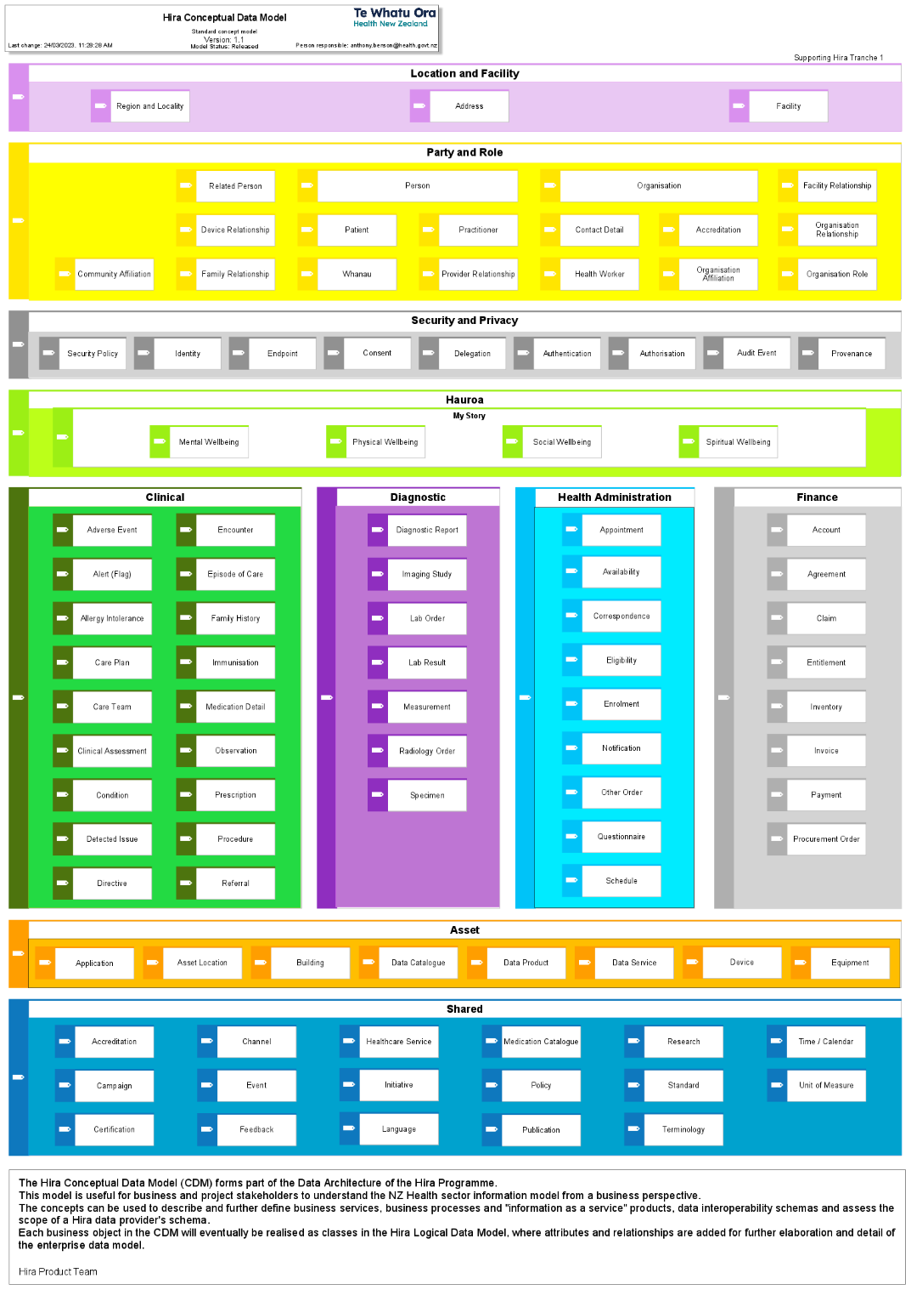

Architecture Principles
Hira-specific guiding principles are repeated from the Business Case architecture.
Principle | Description | Rationale
Data remains at source | This principle indicates that wherever possible, practical, and without affecting performance, data will be dynamically retrieved from source organisations. | - Data at source is original data, therefore quality, curation, and management remain at source.  - Reduces data duplication and management burdens.
Abstraction by design | Architecture building blocks are designed and implemented in such a way that they can be changed or removed without needing to change any upstream or downstream building blocks. | - New requirements can be satisfied in a timely, efficient and economical way.  - Minimise impact from component changes.  - Appropriate technology independence reduces technology lock-in.  - Supports multi-speed changes per building block.  - Allows components to be sourced and supported from multiple agencies.
Publish and subscribe | Changed data events from data providers will be published and notified to subscribers. | - Supports real-time distribution of data changes to multiple subscribers.  - Publisher can “fire-and-forget", relying on a broker to manage distribution of data changes.  - Subscribers take responsibility for applying received changes (how, when and where).  - Supports the creation of the record location service needed by Hira.
Cloud first | At all times technology services will be delivered with low technology debt, by subscribing all services on a run-rate basis, cloud-based service consumptive model. Particularly focusing on software as a service and platform as a service. | - Enables elastic service use required for the rapid scale up/down of Hira services.  - Leverages public reusable services (and associated rapid development of these).  - Supports Government Chief Digital Office (GCDO) service first technology choice.  - Enables move to SaaS and PaaS as primary service consumption models (in line with GCDO strategy).

Deployment Considerations
The following considerations are common to any technology solution realising the reference architecture.
Further descriptions of the deployment considerations can be found in the programme’s non-functional requirements (Section 2.6 of the Hira Tranche 1 – High Level Requirements).

Scalability
Scalability is a critical consideration for the Connector Platform and the associated Information Products, as they must be able to handle an increasing demand as use of the system grows. To ensure scalability, the platform must be designed with a distributed architecture that can scale horizontally by adding more nodes as needed. Additionally, the platform should be able to handle load balancing to distribute requests and processing tasks across multiple nodes.

Resilience and fault tolerance
Resilience and fault tolerance are critical considerations for the Connector Platform as it needs to ensure that Information Products can continue to operate even in the face of failures or disruptions.
To achieve resilience, Connector Platform will be designed with redundancy and failover mechanisms to ensure that processing can continue in the event of a network, node or system failure. This can be achieved using load balancing and multiple instances of services running in parallel. Additionally, the platform should include automated recovery and self-healing capabilities to detect and recover from failures without requiring manual intervention.
Fault tolerance requires designing the platform with an ability to identify and handle errors and exceptions that may arise during request servicing. The Information Products must also include robust error handling and retry mechanisms to ensure that failed requests are handled gracefully and retried or rescheduled for processing to prevent data loss or corruption. Additionally, the platform should support data backup and recovery mechanisms to enable rapid recovery in the event of data loss or corruption.

Disaster recovery
The Connector Platform will increasing become a vital component at national level in the NZ health system. It is therefore expedient to ensure that disaster recovery (DR) capability is provided for in the technology solution design. Refer to the Hira Disaster Recovery Framework for further guidance.

Security, monitoring, and observability
It is expected that the Connector Platform will align with the extensive security, monitoring and observability requirements and guidance of the Hira Programme. Refer to the Observability and Security sections of this document.

Delivery Approach
This section describes the high-level approach for the delivery of the Connector Platform. This includes the creation of the design artefacts from requirements, the approach to sourcing the Connector Platform components and a high-level roadmap for the Platform’s implementation.

Architecture Development Method
The overall design process will use and create artefacts as depicted in the diagram below.

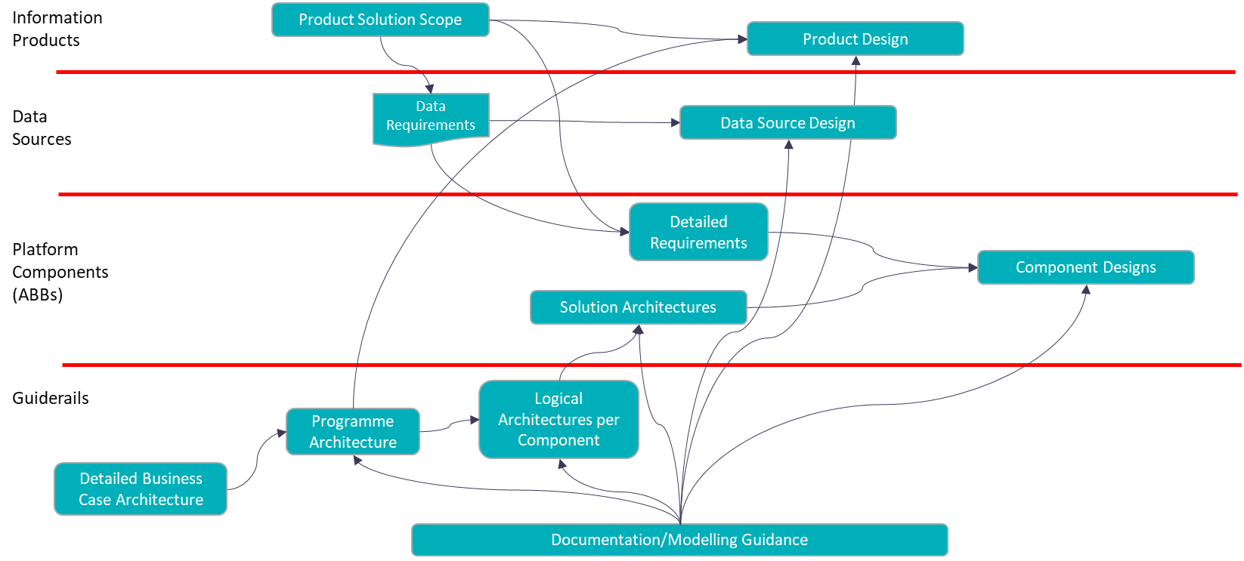

The Programme Architecture will be expressed in terms of this document and as a reference architecture on Confluence. Logical architectures for each building block will be produced to guide selection and implementation of platform components, with solution architectures and detailed designs being further developed as products are selected.
Information Product requirements will drive the requirements for data, which in turn will inform how data sources will be integrated to service API Product designs.

Procurement and Operating Model Approach
Hira will leverage a combination of internal Te Whatu Ora and experienced delivery partners to help make and implement technology choices for the Connector Platform. The same or more resources will be engaged to then build the information products to deliver value to the sector. The programmes preference is to not build internal capability where capable partners exist in the market already. This will apply to both delivery and operations of the Hira Connector Platform and accompanying Products.

Technology Dependencies Map
The Hira PMO and Product Management workstreams have drafted a Hira Programme Implementation Plan (HPIP) for Tranche 1 including an indicative timeline. In particular, the Hira plan on a page can be found here.

The HPIP is dependent on foundational capabilities being available for the roll out of data products and other value-added services. For the HPIP to be fully de-risked, an understanding of the deployment sequence of Hira components is required. This is shown in the diagram below.

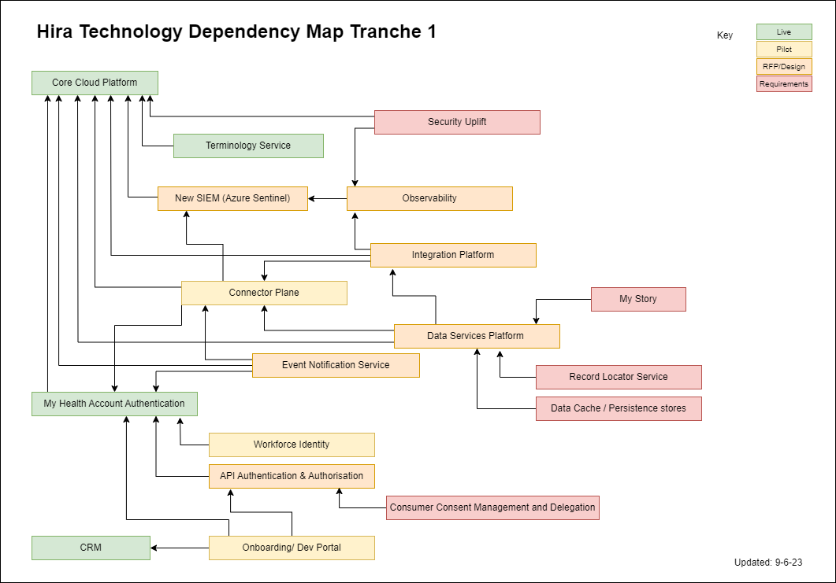

The arrows in the diagram point to dependent components that need to be available (or at a sufficient level of maturity) before the precedent components can be deployed into production.
The colour coding indicates the current state of each component as of June 2023.
This map will be updated periodically to reflect the state of the Hira deployment.

Variations from DBC Architecture
The detailed business case assumed there would be a set of regional health information platforms to pull information from and synchronise information changes with. Since the health sector reforms, new regional information platforms, such as RCCC will be client systems of the Hira Connector Platform for national data sets, i.e. they will utilise information from the Hira Connector Platform. Where they collect regional specific information, they may also provide this information to the Hira Platform. Consequently, the nature of the relationship is likely to be more nuanced than a purely hierarchical one.

Risks, Assumptions and Decisions

Architecture Risks
ID | Risk Summary | Likelihood | Impact | Mitigations
1 | Health NZ is the System Integrator and does not have deep experience in owning the delivery of business outcomes that require complex system integration of multi-vendor Sources of Truth and Systems of Record with differing levels of data quality. | High | High | Procure an experienced SI partner to support the delivery.
2 | Iterative evolution of target architecture may uncover gaps in technology selected. | High | High | Implement core platform and representative set of information products rapidly by prototyping the platform ahead of formal procurement, and plan for a period of rework.
3 | If owners of Sources of Truth and Systems of Record block access to allow the programme to understand the data quality and lineage of data sources, then we can’t build confidence that we can build and deliver secure and usable products leading to scrap, re-work and loss of consumer confidence. | High | High | Perform early data modelling, data quality and lineage assessments which will identify remediation actions required to meet Hira data quality and security standards
4 | If we do not have centralised ownership and management of Customer Lifecycle/Experience, then we risk creating a siloed set of processes and data to manage Hira Customers. | Medium | Medium | Identify an empowered owner of Customer Experience and Lifecycle Management and leverage as a Service Provider to Hira.

Architecture Assumptions
Assumptions being made in this architecture are recorded in the Hira Architecture Assumptions Register page. This is a living register and will continue to be updated as the programme evolves.

Architecture Decisions
This document and subsequent design documents contain decisions that are endorsed with this document. Further details of these decisions and other architectural decisions are recorded in the:
📝 Hira Architecture Decision Log
This log is a living register of decisions and will continue to be added to as the programme evolves.

Glossary of Terms
Below is a selected set of terms used in this document.
The Hira PMO maintains a Glossary located here.
Term | Description
ABB | Architecture Building Block
API | Application Programming Interface
ARIS | A process and architecture modelling tool of Software AG used by the Hira and HSAAP programmes. See https://ariscloud.com/aris-basic/
CDM | Conceptual Data Model
DBC | Detailed Business Case (of Hira)
HPIP | Hira Programme Implementation Plan (aka Hira Plan on a page)
IdAM | Identity and Access Management
RCCC | Regional Collaborative Community Care

API stands for Application Programming Interface. An API is a combined set of technology, rules and practices that enable different applications to communicate with each other. It acts as an intermediary layer that enables data transfers between systems, letting companies open their application data and functionality to external developers, partners, and other departments within their organisation.
Common Person Number, the identifier used for Health Practitioners and Health Service Workforce in the Health Provider Index (HPI).

